***Pizza Sales SQL Queries***

**A.KPI’s**

**1.Total Revenue**

select sum(total_price) as Total_Revenue from pizza_sales

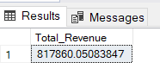

**2.Average Order Value**

select (sum(total_price) / count(Distinct order_id)) as Average_Order_Value from pizza_sales

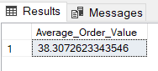

**3.Total Pizzas Sold**

select sum(quantity) as Total_Pizzas_Sold from pizza_sales

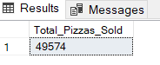

**4.Total Orders**

select count(distinct order_id) as Total_Orders from pizza_sales

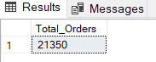

**5.Average Pizzas Per Order**

select sum(quantity) / count(distinct order_id) as Average_Pizzas_Per_Order from pizza_sales

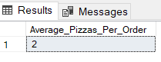

**B.Charts Requirement**

**1.Daily Trend For Total Orders**

select DATENAME(DW, order_date) as Order_Day,

count(distinct order_id) as Total_Order

from pizza_sales

group by DATENAME(DW, order_date)

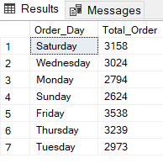

**2.Hourly Trend For Total Orders**

select datepart(hour, order_time) as Order_Hours,

count(distinct order_id) as Total_Order

from pizza_sales

group by datepart(hour, order_time)

order by datepart(hour, order_time)

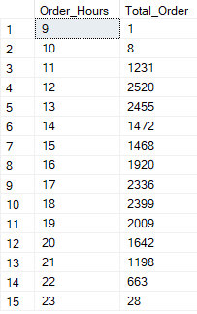

**3.Percentage of Sales by Pizza Category**

Select pizza_category,sum(total_price) as Total_Sales, sum(total_price) * 100 / (select sum(total_price) from pizza_sales)

as Percentage_PizzaCategory from pizza_sales

group by pizza_category

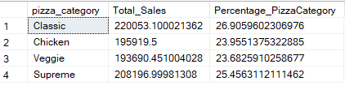

**4.Percentage of Sales by Pizza Size**

Select pizza_size,sum(total_price) as Total_Sales, sum(total_price) * 100 / (select sum(total_price) from pizza_sales)

as Percentage_PizzaSize from pizza_sales

group by pizza_size

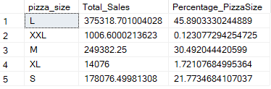

**5.Total Pizzas Sold By Pizza Category**

Select pizza_category, sum(quantity) as Total_Pizzas_Sold

From pizza_sales

group by pizza_category

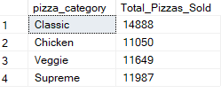

**6.Top 5 Best Sellers By Total Pizzas Sold**

Select top 5 pizza_name,sum(quantity) as Total_Pizzas_Sold

from pizza_sales

group by pizza_name

order by sum(quantity) desc

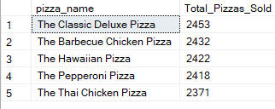

**7.Bottom 5 Worst Sellers By Total Pizzas Sold**

Select top 5 pizza_name,sum(quantity) as Total_Pizzas_Sold

from pizza_sales

group by pizza_name

order by sum(quantity)

